**NAMA : LAILI IFTITAH**

**NIM : 2000018242**

**KELAS : B**

**TUGAS 6 : PKPL**

**SKENARIO PENGUJIAN MANUAL**

**A. Listing Coding (Form Edit Data Penduduk)**

**“simnag_biodata_edit2.php”**

<!doctype html>

<html class="no-js " lang="en">

<head>

<meta charset="utf-8">

<meta http-equiv="X-UA-Compatible" content="IE=Edge">

<meta content="width=device-width, initial-scale=1, maximum- scale=1, user-scalable=no" name="viewport">

<meta name="description" content="Responsive Bootstrap 4 and web Application ui kit.">

<title>:: SIMNag :: Home</title>

<link rel="icon" href="" type="image/x-icon"> <!-- Favicon-->

<link rel="stylesheet" href="[assets/plugins/bootstrap/css/bootstrap.min.css](view-source:http://www.kamangmudiak.id/user/assets/plugins/bootstrap/css/bootstrap.min.css)">

<link rel="stylesheet" href="[assets/plugins/jvectormap/jquery- jvectormap-2.0.3.min.css](view-source:http://www.kamangmudiak.id/user/assets/plugins/jvectormap/jquery-jvectormap-2.0.3.min.css)"/>

<link rel="stylesheet" href="[assets/plugins/charts-c3/plugin.css](view-source:http://www.kamangmudiak.id/user/assets/plugins/charts-c3/plugin.css)"/>

<link rel="stylesheet" href="[assets/plugins/morrisjs/morris.min.css](view-source:http://www.kamangmudiak.id/user/assets/plugins/morrisjs/morris.min.css)" />

<!-- Custom Css -->

<link rel="stylesheet" href="[assets/css/style.min.css](view-source:http://www.kamangmudiak.id/user/assets/css/style.min.css)">

<link rel="stylesheet" href="[assets/plugins/bootstrap/css/bootstrap.min.css](view-source:http://www.kamangmudiak.id/user/assets/plugins/bootstrap/css/bootstrap.min.css)">

<!-- Bootstrap Material Datetime Picker Css -->

<link href="[assets/plugins/bootstrap-material- datetimepicker/css/bootstrap-material-datetimepicker.css](view-source:http://www.kamangmudiak.id/user/assets/plugins/bootstrap-material-datetimepicker/css/bootstrap-material-datetimepicker.css)" rel="stylesheet" />

<!-- Bootstrap Select Css -->

<link href="[assets/plugins/bootstrap-select/css/bootstrap- select.css](view-source:http://www.kamangmudiak.id/user/assets/plugins/bootstrap-select/css/bootstrap-select.css)" rel="stylesheet" />

<!-- Custom Css -->

<link rel="stylesheet" href="[assets/css/style.min.css](view-source:http://www.kamangmudiak.id/user/assets/css/style.min.css)">

</head>

<a href="[https://api.whatsapp.com/send?phone=6285271805037&text=Hola%2 1%20Quisiera%20m%C3%A1s%20informaci%C3%B3n%20sobre%20Varela%202.](https://api.whatsapp.com/send?phone=6285271805037&text=Hola%252%091%20Quisiera%20m%C3%A1s%20informaci%C3%B3n%20sobre%20Varela%202.)" class="float20" target="_blank">

<i style="font-size:50px; text-align:center;" class="zmdi zmdi-hc- fw"></i>

</a>

<style type="text/css">

.float20{

position:fixed;

width:60px;

height:60px;

bottom:40px;

right:40px;

background-color:RED;

color:#FFF;

border-radius:50px;

text-align:center;

box-shadow: 2px 2px 3px #999;

z-index:50;

}

.my-float20{

margin-top:16px;

}

</style>

<body class="theme-blush">

<!-- Page Loader -->

<div class="page-loader-wrapper">

<div class="loader">

<div class="m-t-30"><img class="zmdi-hc-spin" src="" width="48" height="48" alt="SISTEM INFORMASI NAGARI"></div>

<p>Please wait...</p>

</div>

</div>

<!-- Overlay For Sidebars -->

<div class="overlay"></div>

<!-- Left Sidebar -->

<aside id="leftsidebar" class="sidebar">

<div class="navbar-brand">

<button class="btn-menu ls-toggle-btn" type="button"><i class="zmdi zmdi-menu"></i></button>

<a href="[index.php](view-source:http://www.kamangmudiak.id/user/index.php)"><img src="[assets/images/KM_logo.png](view-source:http://www.kamangmudiak.id/user/assets/images/KM_logo.png)" style="width: 180px; height: auto;" width="25" alt="Aero"></a>

</div>

<div class="menu">

<ul class="list">

<li><a href="[index.php](view-source:http://www.kamangmudiak.id/user/index.php)"><i class="zmdi zmdi-home"></i><span>Beranda</span></a></li>

<li class="active open"><a href="[simnag_biodata.php](view-source:http://www.kamangmudiak.id/user/simnag_biodata.php)" ><i class="zmdi zmdi-hc-fw"></i><span>Data Pribadi</span></a>

</li>

<li><a href="[simnag_status.php](view-source:http://www.kamangmudiak.id/user/simnag_status.php)" ><i class="zmdi zmdi-hc-fw"></i><span>Status</span></a>

</li>

<li style="display: none;"><a href="[simnag_surat_01.php](view-source:http://www.kamangmudiak.id/user/simnag_surat_01.php)" ><i class="zmdi zmdi-hc-fw"></i> <span>Permohonan</span></a>

</li>

<li ><a href="[simnag_lapor.php](view-source:http://www.kamangmudiak.id/user/simnag_lapor.php)"><i class="zmdi zmdi-hc-fw"></i> <span>Aduan/Aspirasi</span></a></li>

<li ><a href="[logout.php](view-source:http://www.kamangmudiak.id/user/logout.php)"><i class="zmdi zmdi-power"></i><span>Log out</span></a></li>

</ul>

</div>

</aside>

<!-- Right Sidebar -->

<aside id="rightsidebar" class="right-sidebar">

<ul class="nav nav-tabs sm">

<li class="nav-item"><a class="nav-link active" data-toggle="tab" href="[#setting](view-source:http://www.kamangmudiak.id/user/simnag_biodata_edit2.php#setting)"><i class="zmdi zmdi-settings zmdi-hc-spin"></i></a></li>

<li class="nav-item"><a class="nav-link" data-toggle="tab" href="[#chat](view-source:http://www.kamangmudiak.id/user/simnag_biodata_edit2.php#chat)"><i class="zmdi zmdi-comments"></i></a></li>

</ul>

<div class="tab-content">

<div class="tab-pane active" id="setting">

<div class="slim_scroll">

<div class="card">

<h6>Theme Option</h6>

<div class="light_dark">

<div class="radio">

<input type="radio" name="radio1" id="lighttheme" value="light" checked="">

<label for="lighttheme">Light Mode</label>

</div>

<div class="radio mb-0">

<input type="radio" name="radio1" id="darktheme" value="dark">

<label for="darktheme">Dark Mode</label>

</div>

</div>

</div>

<div class="card">

<h6>Color Skins</h6>

<ul class="choose-skin list-unstyled">

<li data-theme="purple"><div class="purple"></div></li>

<li data-theme="blue"><div class="blue"></div></li>

<li data-theme="cyan"><div class="cyan"></div></li>

<li data-theme="green"><div class="green"></div></li>

<li data-theme="orange"><div class="orange"></div></li>

<li data-theme="blush" class="active"><div class="blush"></div></li>

</ul>

</div>

<div class="card">

<h6>General Settings</h6>

<ul class="setting-list list-unstyled">

<li>

<div class="checkbox">

<input id="checkbox1" type="checkbox">

<label for="checkbox1">Report Panel Usage</label>

</div>

</li>

<li>

<div class="checkbox">

<input id="checkbox2" type="checkbox" checked="">

<label for="checkbox2">Email Redirect</label>

</div>

</li>

<li>

<div class="checkbox">

<input id="checkbox3" type="checkbox" checked="">

<label for="checkbox3">Notifications</label>

</div>

</li>

<li>

<div class="checkbox">

<input id="checkbox4" type="checkbox">

<label for="checkbox4">Auto Updates</label>

</div>

</li>

<li>

<div class="checkbox">

<input id="checkbox5" type="checkbox" checked="">

<label for="checkbox5">Offline</label>

</div>

</li>

<li>

<div class="checkbox">

<input id="checkbox6" type="checkbox" checked="">

<label for="checkbox6">Location Permission</label>

</div>

</li>

</ul>

</div>

</div>

</div>

<div class="tab-pane right_chat" id="chat">

<div class="slim_scroll">

<div class="card">

<ul class="list-unstyled">

<li class="online">

<a href="javascript:void(0);">

<div class="media">

<img class="media-object " src="[assets/images/xs/avatar4.jpg](view-source:http://www.kamangmudiak.id/user/assets/images/xs/avatar4.jpg)" alt="">

<div class="media-body">

<span class="name">Sophia <small class="float-right">11:00AM</small></span>

<span class="message">There are many variations of passages of Lorem Ipsum available</span>

<span class="badge badge-outline status"></span>

</div>

</div>

</a>

</li>

<li class="online">

<a href="javascript:void(0);">

<div class="media">

<img class="media-object " src="[assets/images/xs/avatar5.jpg](view-source:http://www.kamangmudiak.id/user/assets/images/xs/avatar5.jpg)" alt="">

<div class="media-body">

<span class="name">Grayson <small class="float-right">11:30AM</small></span>

<span class="message">All the Lorem Ipsum generators on the</span>

<span class="badge badge-outline status"></span>

</div>

</div>

</a>

</li>

<li class="offline">

<a href="javascript:void(0);">

<div class="media">

<img class="media-object " src="[assets/images/xs/avatar2.jpg](view-source:http://www.kamangmudiak.id/user/assets/images/xs/avatar2.jpg)" alt="">

<div class="media-body">

<span class="name">Isabella <small class="float-right">11:31AM</small></span>

<span class="message">Contrary to popular belief, Lorem Ipsum</span>

<span class="badge badge-outline status"></span>

</div>

</div>

</a>

</li>

<li class="me">

<a href="javascript:void(0);">

<div class="media">

<img class="media-object " src="[assets/images/xs/avatar1.jpg](view-source:http://www.kamangmudiak.id/user/assets/images/xs/avatar1.jpg)" alt="">

<div class="media-body">

<span class="name">John <small class="float-right">05:00PM</small></span>

<span class="message">It is a long established fact that a reader</span>

<span class="badge badge-outline status"></span>

</div>

</div>

</a>

</li>

<li class="online">

<a href="javascript:void(0);">

<div class="media">

<img class="media-object " src="[assets/images/xs/avatar3.jpg](view-source:http://www.kamangmudiak.id/user/assets/images/xs/avatar3.jpg)" alt="">

<div class="media-body">

<span class="name">Alexander <small class="float-right">06:08PM</small></span>

<span class="message">Richard McClintock, a Latin professor</span>

<span class="badge badge-outline status"></span>

</div>

</div>

</a>

</li>

</ul>

</div>

</div>

</div>

</div>

</aside>

<!-- Main Content -->

<section class="content">

<div class="">

<img style="width: 100%; height: auto;" src="[assets/images/ok3.png](view-source:http://www.kamangmudiak.id/user/assets/images/ok3.png)">

</div>

</div>

</section>

<section class="content">

<div class="">

<div class="block-header">

<div class="row">

<div class="col-lg-7 col-md-6 col-sm-12">

<h2>Edit Data Penduduk</h2>

</div>

</div>

<div class="row">

<div class="col-lg-7 col-md-6 col-sm-12">

<button class="btn btn-primary btn-icon mobile_menu" type="button"><i class="zmdi zmdi-sort-amount-desc"></i></button>

</div>

</div>

</div>

<div class="container-fluid">

<div class="row clearfix">

<div class="col-lg-12 col-md-12 col-sm-12">

<div class="card">

<div class="body">

<!-- Tab panes -->

<div class="tab-content">

<div role="tabpanel" class="tab-pane in active" >

<p>

<form class="form-horizontal row-fluid" action="[simnag_biodata_edit_pro2.php](view-source:http://www.kamangmudiak.id/user/simnag_biodata_edit_pro2.php)" method="POST" name="form3" onsubmit="return validation()" ">

<div class="row clearfix">

<div class="col-lg-2 col-md-2 col-sm24 form-control-label">

<label for="email_address_2">No KK</label>

</div>

<div class="col-lg-3 col-md-10 col-sm-3">

<div class="form-group">

<input type="text" id="p_kk" readonly name="p_kk" class="form-control" value="123654789" placeholder="" required>

</div>

</div>

</div

<div class="row clearfix">

<div class="col-lg-2 col-md-2 col-sm24 form-control-label">

<label for="email_address_2">Password</label>

</div>

<div class="col-lg-3 col-md-10 col-sm-3">

<div class="form-group">

<input type="text" id="p_password" name="p_password" class="form-control" value="123654789" placeholder="" required>

</div>

</div>

</div><br><br

<div class="row clearfix">

<div class="col-lg-2 col-md-2 col-sm24 form-control-label">

<label for="email_address_2">NIK</label>

</div>

<div class="col-lg-3 col-md-10 col-sm-3">

<div class="form-group">

<input type="text" id="p_nik" name="p_nik" class="form-control" value="1234567890" placeholder="s" required>

</div>

</div>

</div>

<div class="row clearfix">

<div class="col-lg-2 col-md-2 col-sm24 form-control-label">

<label for="email_address_2">Nama</label>

</div>

<div class="col-lg-3 col-md-10 col-sm-3">

<div class="form-group">

<input type="text" id="p_name" name="p_name" class="form-control" value="putri" placeholder="" required>

</div>

</div>

</div>

<div class="row clearfix">

<div class="col-lg-2 col-md-2 col-sm24 form-control-label">

<label for="email_address_2">Hubungan</label>

</div>

<div class="col-lg-3 col-md-10 col-sm-3">

<div class="form-group">

<input type="text" id="p_hub" name="p_hub" readonly class="form-control" value="Kepala Keluarga" placeholder="" required>

</div>

</div>

</div>

<div class="row clearfix">

<div class="col-lg-2 col-md-2 col-sm24 form-control-label">

<label for="email_address_2">No HP</label>

</div>

<div class="col-lg-3 col-md-10 col-sm-3">

<div class="form-group">

<input type="text" id="p_telp" name="p_telp" class="form-control" value="sfdhgfjhkl" placeholder="" required>

</div>

</div>

</div>

<div class="row clearfix">

<div class="col-lg-2 col-md-2 col-sm24 form-control-label">

<label for="email_address_2">Tempat Lahir</label>

</div>

<div class="col-lg-3 col-md-10 col-sm-3">

<div class="form-group">

<input type="text" id="p_l_tempat" name="p_l_tempat" class="form-control" value="" placeholder="" required>

</div>

</div>

</div>

<div class="row clearfix">

<div class="col-lg-2 col-md-2 col-sm24 form-control-label">

<label for="email_address_2">Tanggal Lahir</label>

</div>

<div class="input-group col-md-3">

<div class="input-group-prepend">

<span class="input-group-text"><i class="zmdi zmdi-calendar"></i></span>

</div>

<input type="text" class="form-control datepicker" id="p_l_tanggal" name="p_l_tanggal" value="" placeholder="Belum di isi.." required>

</div>

</div><br><br>

<div class="row clearfix">

<div class="col-lg-2 col-md-2 col-sm24 form-control-label">

<label for="email_address_2">Jenis Kelamin</label>

</div>

<div class="col-lg-3 col-md-10 col-sm-3">

<div class="form-group">

<select class="form-control show-tick ms select2" id="kelamin" name="kelamin" data-placeholder="Select" required>

<option>Perempuan</option>

<option>Laki-laki</option>

<option>Perempuan</option>

</select>

</div>

</div>

</div>

<div class="row clearfix">

<div class="col-lg-2 col-md-2 col-sm24 form-control-label">

<label for="email_address_2">Suku</label>

</div>

<div class="col-lg-6 col-md-10 col-sm-6">

<div class="form-group">

<input type="text" id="p_suku" name="p_suku" class="form-control" value="" placeholder="---" required>

</div>

</div>

</div>

<div class="row clearfix">

<div class="col-lg-2 col-md-2 col-sm24 form-control-label">

<label for="email_address_2">Agama</label>

</div>

<div class="col-lg-3 col-md-10 col-sm-3">

<div class="form-group">

<select class="form-control show-tick ms select2" id="agama" name="agama" data-placeholder="Select" required>

<option></option>

<option value="Islam">Islam</option>

<option value="Kristen">Kristen</option>

<option value="Katolik">Katolik</option>

<option value="Hindu">Hindu</option>

<option value="Buddha">Buddha</option>

<option value="Konghucu">Konghucu</option>

</select>

</div>

</div>

</div>

<div class="row clearfix">

<div class="col-lg-2 col-md-2 col-sm24 form-control-label">

<label for="email_address_2">Alamat </label>

</div>

<div class="col-lg-6 col-md-10 col-sm-6">

<div class="form-group">

<textarea type="text" id="p_alamat" name="p_alamat" class="form-control" placeholder="" required></textarea>

</div>

</div>

</div>

<br><br>

<div class="row clearfix">

<div class="col-lg-2 col-md-2 col-sm24 form-control-label">

<label for="email_address_2">Pendidikan Terakhir</label>

</div>

<div class="col-lg-3 col-md-10 col-sm-1">

<div class="form-group">

<select class="form-control show-tick ms select2" id="pend" name="pend" data-placeholder="Select" required>

<option></option>

<option>Belum Masuk TK/PAUD</option>

<option>Putus Sekolah</option>

<option>Sedang D-3/Sederajat</option>

<option>Sedang S-1/Sederajat</option>

<option>Sedang S-2/Sederajat</option>

<option>Sedang S-3/Sederajat</option>

<option>Sedang SD/Sederajat</option>

<option>Sedang SMA/Sederajat</option>

<option>Sedang SMP/Sederajat</option>

<option>Sedang TK/PAUD</option>

<option>Tamat D-3/Sederajat</option>

<option>Tamat S-1/Sederajat</option>

<option>Tamat S-2/Sederajat</option>

<option>Tamat S-3/Sederajat</option>

<option>Tamat SD/Sederajat</option>

<option>Tamat SMA/Sederajat</option>

<option>Tamat SMP/Sederajat</option>

<option>Tidak dapat membaca</option>

<option>Tidak Diketahui</option>

<option>Tidak Pernah Sekolah</option>

<option>Tidak Tamat SD/Sederajat</option>

</select>

</div>

</div>

</div>

<div class="row clearfix">

<div class="col-lg-2 col-md-2 col-sm24 form-control-label">

<label for="email_address_2">Nama Instansi</label>

</div>

<div class="col-lg-6 col-md-10 col-sm-6">

<div class="form-group">

<input type="text" id="p_pend_nama" name="p_pend_nama" class="form-control" value="" placeholder="" required>

</div>

</div>

</div><br><br>

<div class="row clearfix">

<div class="col-lg-2 col-md-2 col-sm24 form-control-label">

<label for="email_address_2">Status Pekerjaan</label>

</div>

<div class="col-lg-3 col-md-10 col-sm-4">

<div class="form-group">

<select class="form-control show-tick ms select2" id="pek" name="pek" data-placeholder="Select" required>

<option></option>

<option>AKUNTAN</option>

<option>ANGGOTA BPK</option>

<option>ANGGOTA DPD</option>

<option>ANGGOTA DPR RI</option>

<option>ANGGOTA DPRD KAB. KOTA</option>

<option>ANGGOTA DPRD PROP</option>

<option>ANGGOTA MAHKAMAH KONSTITUSI</option>

<option>APOTEKER</option>

<option>ARSITEK</option>

<option>BELUM/TIDAK BEKERJA</option>

<option>BIARAWATI</option>

<option>BIDAN</option>

<option>BUPATI</option>

<option>BURUH HARIAN LEPAS</option>

<option>BURUH MIGRAN</option>

<option>BURUH NELAYAN/PERIKANAN</option>

<option>BURUH PETERNAKAN</option>

<option>BURUH TANI/PERKEBUNAN</option>

<option>DOKTER</option>

<option>DOSEN</option>

<option>DUTA BESAR</option>

<option>GUBERNUR</option>

<option>GURU</option>

<option>IMAM MASJID</option>

<option>INDUSTRI</option>

<option>JURU MASAK</option>

<option>KARYAWAN BUMN</option>

<option>KARYAWAN HONORER</option>

<option>KARYAWAN SWASTA</option>

<option>KEPALA DESA</option

<option>KEPOLISIAN RI</option>

<option>KONSTRUKSI</option>

<option>KONSULTAN</option>

<option>MEKANIK</option>

<option>MENGURUS RUMAH TANGGA</option>

<option>NELAYAN/PERIKANAN</option>

<option>NOTARIS</option>

<option>PARAJI</option>

<option>PARANORMAL</option>

<option>PASTOR</option>

<option>PEDAGANG</option>

<option>PEGAWAI NEGERI SIPIL (PNS)</option>

<option>PELAJAR/MAHASISWA</option>

<option>PELAUT</option>

<option>PEMBANTU RUMAH TANGGA</option>

<option>PENATA BUSANA</option>

<option>PENATA RAMBUT</option>

<option>PENATA RIAS</option>

<option>PENDETA</option>

<option>PENELITI</option>

<option>PENGACARA</option>

<option>PENSIUNAN</option>

<option>PENTERJEMAH</option>

<option>PENYIAR RADIO</option>

<option>PENYIAR TELEVISI</option>

<option>PERANCANG BUSANA</option>

<option>PERANGKAT DESA</option>

<option>PERAWAT</option>

<option>PERDAGANGAN</option>

<option>PETANI/PEKEBUN</option>

<option>PETERNAK</option>

<option>PIALANG</option>

<option>PILOT</option>

<option>PRESIDEN</option>

<option>PROMOTOR ACARA</option>

<option>PSIKIATER/PSIKOLOG</option>

<option>SENIMAN</option>

<option>SOPIR</option>

<option>TABIB</option>

<option>TENTARA NASIONAL INDONESIA (TNI)</option>

<option>Tidak Diketahui</option>

<option>TRANSPORTASI</option>

<option>TUKANG BATU</option>

<option>TUKANG CUKUR</option>

<option>TUKANG GIGI</option>

<option>TUKANG JAHIT</option>

<option>TUKANG KAYU</option>

<option>TUKANG LAS/PANDAI BESI</option>

<option>TUKANG LISTRIK</option>

<option>TUKANG SOL SEPATU</option>

<option>USTADZ/MUBALIGH</option>

<option>WAKIL BUPATI</option>

<option>WAKIL GUBERNUR</option>

<option>WAKIL PRESIDEN</option>

<option>WAKIL WALIKOTA</option>

<option>WALIKOTA</option>

<option>WARTAWAN</option>

<option>WIRASWASTA</option>

</select>

</div>

</div>

</div>

<div class="row clearfix">

<div class="col-lg-2 col-md-2 col-sm24 form-control-label">

<label for="email_address_2">Nama Instansi</label>

</div>

<div class="col-lg-6 col-md-10 col-sm-6">

<div class="form-group">

<input type="text" id="p_pek_nama" name="p_pek_nama" class="form-control" value="" placeholder="" required>

</div>

</div>

</div>

<div class="col-sm-8 offset-sm-2">

<a style="background-color: grey; font-weight:bold; " href="[simnag_biodata.php](view-source:http://www.kamangmudiak.id/user/simnag_biodata.php)" type="button" class="btn btn-raised btn-primary btn-round waves-effect">KEMBALI</a>

<a style="background-color: #46b6fe; font-weight:bold; font-size:12px;" type="submit" href="javascript: submitform()" name="submit" class="button btn login100-form-btn">UBAH</a>

</div>

</form>

</p>

</div>

</div>

</div>

<div class="body">

</div>

</div>

</div>

</div>

<div class="row clearfix">

<div class="col-lg-12 col-md-12 col-sm-12">

</div>

</div>

</div>

</section>

<script type="text/javascript">

function submitform()

{

document.form3.submit();

}

</script>

<!-- Jquery Core Js -->

<script src="[assets/bundles/libscripts.bundle.js](view-source:http://www.kamangmudiak.id/user/assets/bundles/libscripts.bundle.js)"></script> <!-- Lib Scripts Plugin Js ( jquery.v3.2.1, Bootstrap4 js) -->

<script src="[assets/bundles/vendorscripts.bundle.js](view-source:http://www.kamangmudiak.id/user/assets/bundles/vendorscripts.bundle.js)"></script> <!-- slimscroll, waves Scripts Plugin Js -->

<script src="[assets/bundles/jvectormap.bundle.js](view-source:http://www.kamangmudiak.id/user/assets/bundles/jvectormap.bundle.js)"></script> <!-- JVectorMap Plugin Js -->

<script src="[assets/bundles/sparkline.bundle.js](view-source:http://www.kamangmudiak.id/user/assets/bundles/sparkline.bundle.js)"></script> <!-- Sparkline Plugin Js -->

<script src="[assets/bundles/c3.bundle.js](view-source:http://www.kamangmudiak.id/user/assets/bundles/c3.bundle.js)"></script>

<script src="[assets/plugins/bootstrap-material-datetimepicker/js/bootstrap-material-datetimepicker.js](view-source:http://www.kamangmudiak.id/user/assets/plugins/bootstrap-material-datetimepicker/js/bootstrap-material-datetimepicker.js)"></script>

<script src="[assets/bundles/libscripts.bundle.js](view-source:http://www.kamangmudiak.id/user/assets/bundles/libscripts.bundle.js)"></script> <!-- Lib Scripts Plugin Js -->

<script src="[assets/bundles/vendorscripts.bundle.js](view-source:http://www.kamangmudiak.id/user/assets/bundles/vendorscripts.bundle.js)"></script> <!-- Lib Scripts Plugin Js -->

<script src="[assets/plugins/momentjs/moment.js](view-source:http://www.kamangmudiak.id/user/assets/plugins/momentjs/moment.js)"></script> <!-- Moment Plugin Js -->

<!-- Bootstrap Material Datetime Picker Plugin Js -->

<script src="[assets/plugins/bootstrap-material-datetimepicker/js/bootstrap-material-datetimepicker.js](view-source:http://www.kamangmudiak.id/user/assets/plugins/bootstrap-material-datetimepicker/js/bootstrap-material-datetimepicker.js)"></script>

<script src="[assets/bundles/mainscripts.bundle.js](view-source:http://www.kamangmudiak.id/user/assets/bundles/mainscripts.bundle.js)"></script><!-- Custom Js -->

<script src="[assets/js/pages/forms/basic-form-elements.js](view-source:http://www.kamangmudiak.id/user/assets/js/pages/forms/basic-form-elements.js)"></script>

</body>

</html>

**B. URL Website SIMNAG :**

<http://www.kamangmudiak.id>

<http://www.kamangmudiak.id/user/simnag_biodata_edit2.php>

**C. Capture Form**

1. **Tampilan beranda website SIMNAG**

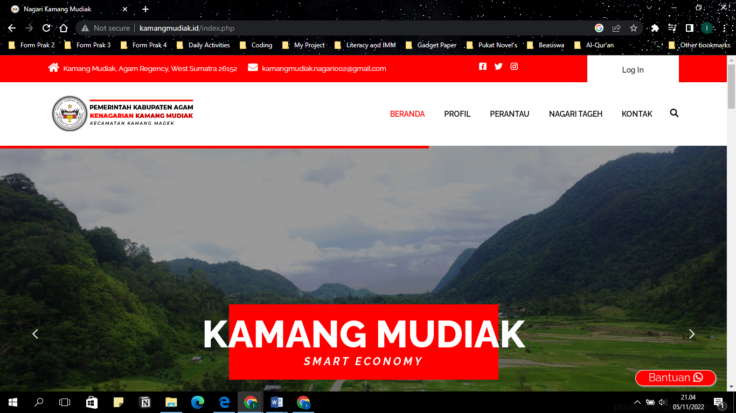

1. **Form Edit Data Penduduk (Yang Akan Diuji)**

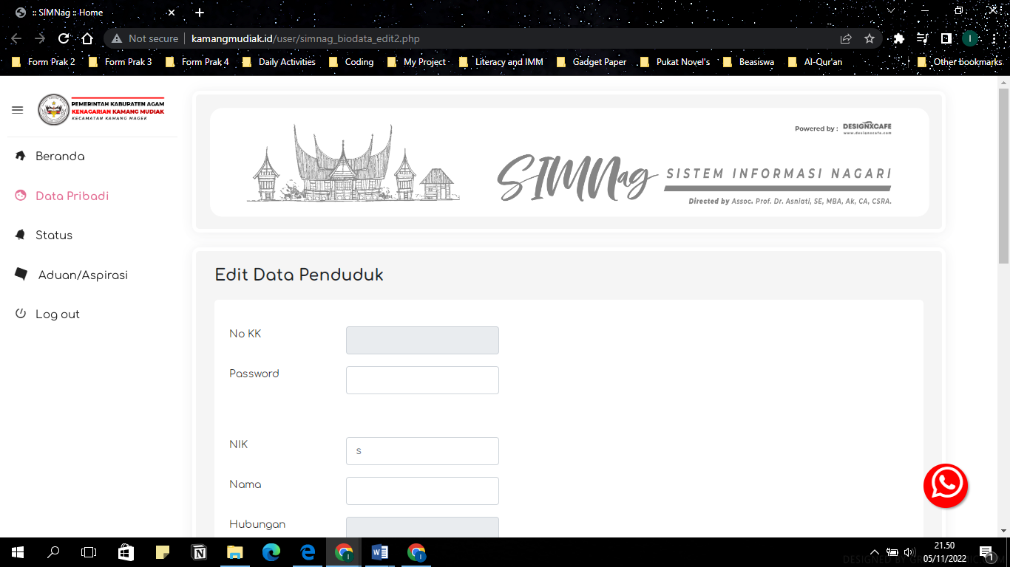

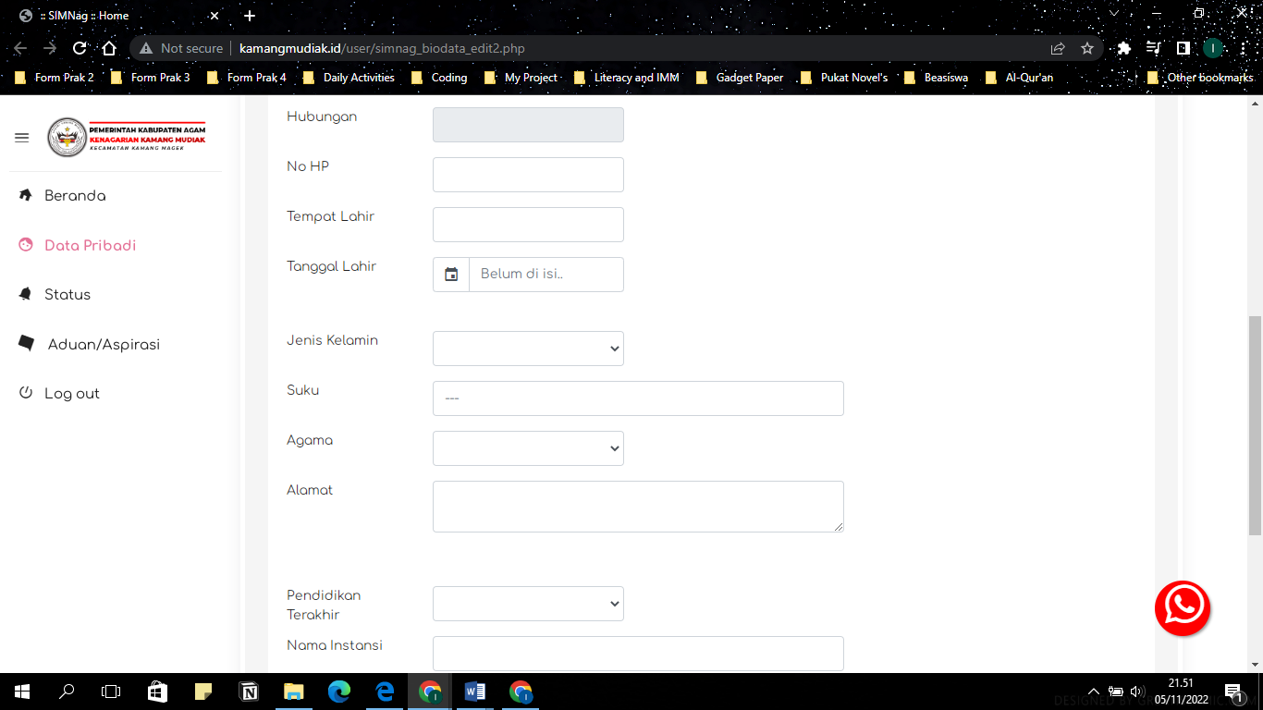

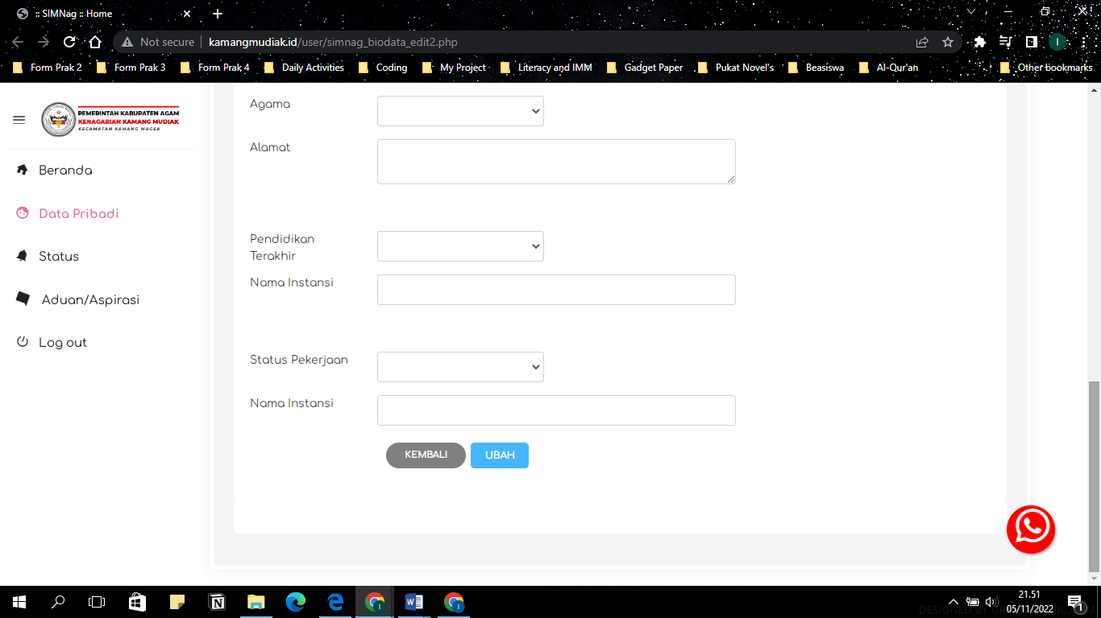

**D. Skenario Pengujian (Form Ubah Data Penduduk)**

|  |  |  |  |
| --- | --- | --- | --- |
| **No** | **Skenario Pengujian** | **Hasil Yang Diharapkan** | **Capture Form** |
| 1 | Mengisi NIK dengan “2000018242”, nama dengan “Laili Iftitah”, Hubungan dengan memilih “Kepala Keluarga”, no HP dengan “082123456789”, Tempat Lahir dengan “Yogyakarta”, Tanggal Lahir dengan “28 February 2002”, Jenis kelamin dengan memilih “perempuan”, suku dengan “Jawa”, agama dengan “Islam”, Alamat dengan “Sleman Yogyakarta”, pendidikan terakhir dengan memilih “SMA/sederajat”, instansi dengan “SMKN 1 Yogyakarta”, Pekerjaan dengan memilih “Pelajar/Mahasiswa” dan instansi dengan “Universitas Ahmad Dahlan” kemudian klik Ubah | Pesan akan menampilkan “Update Succesfull”, kemudian semua data yang ditambahkan disimpan ke dalam Database untuk NIK, Nama, Hubungan, No HP Tempat Lahir, Tanggal Lahir, Jenis Kelamin, Suku, Agama, Alamat, Pendidikan Terakhir, Instansi, Pekerjaan, dan Instansi. |  |
| 2 | Mengubah NIK dengan karakter huruf angka dan simbol “abc@@123” dan no HP dengan “abc123456@#$” kemudian klik “Ubah” | Pesan akan menampilkan “Data Yang dimasukkan invalid” |  |
| 3 | Mengubah Tanggal lahir hannya berisi tahun atau bulan saja “2002” atau “February” | Tidak bisa hanya diisi tanggal/bulan/tahun saja. Sistem akan menampilkan kalender secara lengkap kemudian baru bisa dipilih tanggal yang tepat. |  |
| 4 | Mengubah Jenis Kelamin dengan mengisi selain yang ada dipilihan “Perempuan” dan “Laki-laki” dengan karakter dalam bentuk apapun. | Tidak bisa mengisi jenis kelamin selain dari pilihan yang sediakan karena sistem hanya bisa diisi dengan pilihan bukan dengan pengisian manual. |  |
| 5 | Mengubah Agama dengan mengisi selain yang ada dipilihan “Islam”, “Kristen”, “Katolik”, “Hindu”, “Budha”, “Konghuchu”, dengan karakter dalam bentuk apapun. | Tidak bisa mengisi jenis kelamin selain dari pilihan yang sediakan karena sistem hanya bisa diisi dengan pilihan bukan dengan pengisian manual |  |
| 6 | Mengisi atau megubah kolom suku dan alamat dengan isian berupa huruf dan angka serta dalam jumlah karakter yang banyak melebihi 20 karakter seperti “ Rt 100 Rw 200 Sendangadi, Ngaglik, Sleman, Yogyakarta” kemudian klik “Ubah” | Pesan akan menampilkan “Update Succesfull” dan data yang diperbarui akan tersimpan ke dalam database sistem. |  |
| 7 | Mengisi atau mengubah kolom pendidikan terakhir dan juga pekerjan berupa huruf, angka dan karakter lainya selain yang ada dipilihan seperti “Lulusan SI” dan “Wurausaha” kemudian klik “Ubah” | Pesan tidak akan menampilkan “Update Successfull” karena sistem menolak menyimpan data selain dari kotak pilihan yang disediakan. |  |
| 8 | Mengubah No KK dan NIK menjadi kosong atau mengisi dengan karakter lain selain angka seperti “abc12234bcd” | Tidak dapat tersimpan karena sistem menolak kolom NIK dan No KK kosong. Saat membuka form ubah, kolom NIK dan No KK sudah terisi secara otomatis saat pendaftaran sehingga tidak bisa kosong. Dan Pesan tidak akan menampilkan “Update Successfull” ketika di klik “Ubah” |  |
| 9 | Mengubah isi kolom nama dengan karakter selain huruf seperti “Laili 123 @@##” Kemudian klik “Ubah”. | Sistem tidak dapat menyimpan karakter selain huruf pada kolom nama, sehingga tidak muncul pesan “Update Successfull” tetapi seharusnya “Character Invalid”. |  |
| 10 | Mengubah isis kolom instansi dengan karakter selain huruf seperti “Universitas Ahmad Dahlan” atau dengan kombinasi karakter angka “SMMKN 1 Yogyakarta” kemudian klik “Ubah”. | Sistem akan menyimpan karakter yang terisis di kolom instansi dengan berbagai jenis seperti hufuf besar,kecil dan angka. Pesan akan menampilkan “Update Successfull”. |  |